HOTEL MANAGEMENT SYSTEM
Mini Project submitted in partial fulfilment of the requirements for the Degree of

BACHELORS OF TECHNOLOGY
in
COMPUTER SCIENCE AND ENGINEERING
By
11614774 Yash Pratap Singh B35
11610372 Shankar Bhumireddy A10
11603432 Sai Prabhakar A26

Under the Guidance of
Ms.Deepika


School of Computer Science and Engineering
Lovely Professional University
Phagwara, Punjab (India)
APRIL 2017
DECLARATION STATEMENT

We hereby declare that the work reported in the Mini Project entitled "HOTEL MANAGEMENT SYSTEM” in partial fulfillment of the requirement for the award of Degree for Bachelors of Technology in Computer Science and Engineering at Lovely Professional University, Phagwara, Punjab is an authentic work carried out under the guidance of Ms.Deepika.

Place : Lovely Professional University Name of students: 11614774 Yash Pratap Singh
Date:11-04-17 11610372 Shankar Bhumireddy
11603432 Sai Prabhakar
ACKNOWLEDGEMENT

I would like to express my special thanks of gratitude to my teacher Ms. Deepika who gave me the golden opportunity to do this wonderful project on the topic HOTEL MANAGEMENT SYSTEM, which also helped me in doing a lot of Research and i came to know about so many new things I am really thankful to them.
Secondly i would also like to thank my friends who helped me a lot in finalizing this project within the limited time frame.

Place : Lovely Professional University 11614774 Yash Pratap Singh
Date : 11.04.2017 11610372 Shankar Bhumireddy
11603432 Sai Prabhakar

TABLE OF CONTENT

CHAPTER 1: INTRODUCTION
CHAPTER 2: METHODOLOGY
1.Flowchart
2. Grant chart
CHAPTER 3: IMPLEMENTATION
1.Home page
2. Reservation page
3. Menu

INTRODUCTION
Hotel is a place where all who conduct themselves properly, and who being able to pay and ready to pay for there entertainment, are received, if there be accommodation for them, who without any stipulated engagement as to the duration of their stay or as to the compensation, are while there, supplied at reasonable cause with there meals, lodging and other services and attention as are necessarily incident to the use as a temporary home.
The motive of our is to control various activities perform in the hotel using the computer with work of “HOTEL MANAGEMENT SYSYTEM”. From the beginning the important thing in our mind is that we should concentrate our project work on a subject that is easy to understand and is according our daily requirement.
In the present time there is a great rush in hotels, as these have become necessity for middle and upper class of the society, people travel a lot, stays in hotels, goes to the hotels for functions, meeting and refreshment. Our project is developed keeping in mind the general needs of the customers when he goes to the hotel.
A Hotel or inn may also be defined as an establishment whose primary business is providing lodging facilities for the general public and which furnishes one or more of the following services
(a)Food and Beverage service
(b)Room service
(c) Uniformed service
(d) Laundry service and
(e) Use of furniture etc.

flow chart

Home Page

Reservation page
Gallery
Menu
Feedback
Branches
Home
Enter the branch, name, check in and out dates and the room type.

Pay Now
Reset
Home
Book Room
Services
Customer care

Lucknow, Agra, Delhi, Mumbai, Bangalore
Reservation Page
About us

Paytm

Home page
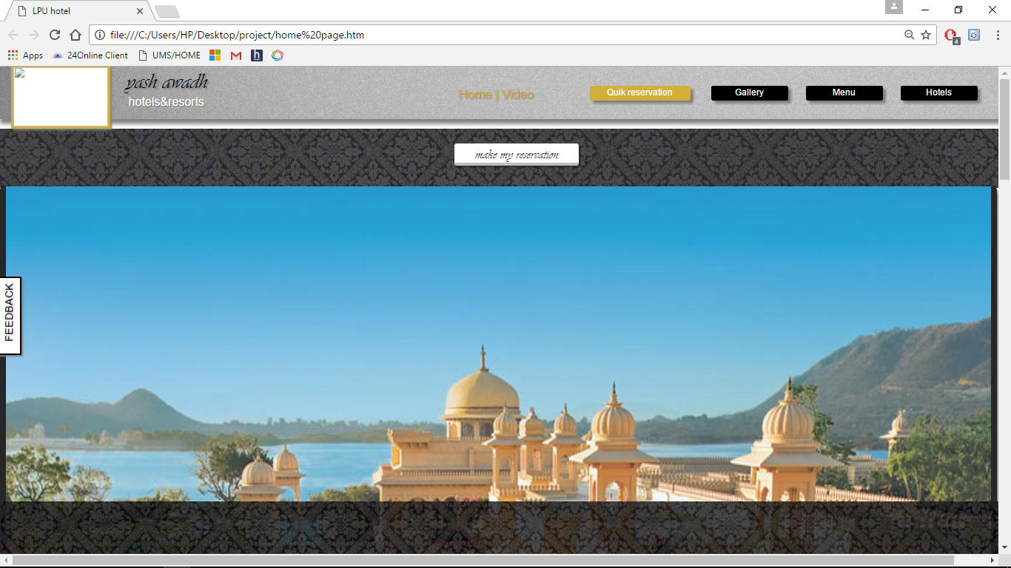
It consists of a links related to the reservation page, Hotel gallery, and the slide show displaying the Images of the Hotel. In our web page there are some sub links such as quick reservation, gallery, menu, Hotels. By clicking on the hotels link it will display the cities where our Hotels are Located. When we click on the video link it will directly goes to the bottom of the page where the videos are located and displays the video. And when we click on the Home link it will directly goes to the bottom of the page where the information about the hotel such as the facilities we provide and the Awards that we have received and the festival offers we have provided etc. Feedback box is also provided to the customers to leave a review about the hotels management, facilities and some suggestions from the them to develop our Hotel.
RESERVATION page
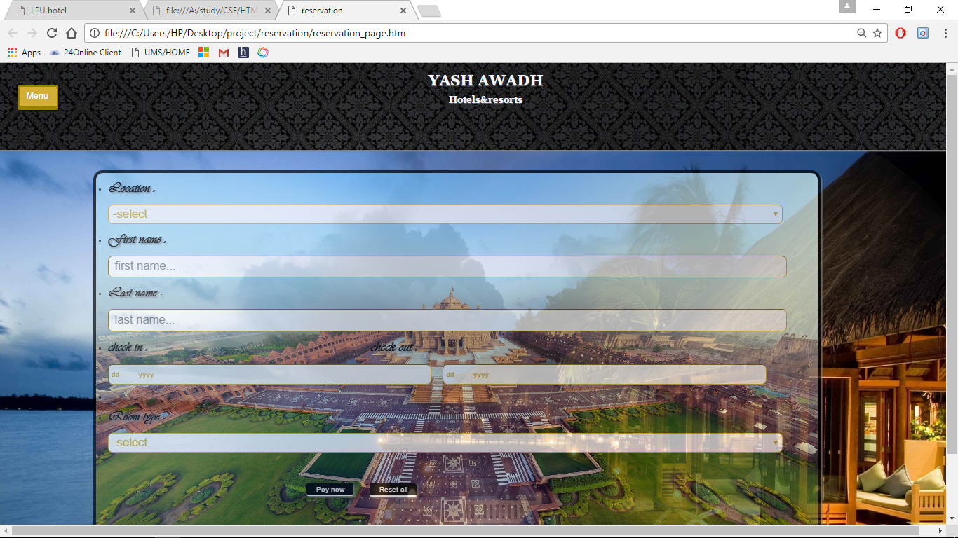
By the link provided in the homepage we can go to the reservation page which is shown above. In the reservation page we can select our location and user have to provide the details like his name check in and check out dates. He can also choose the room type he want such as Premium, presidential suit room and executive rooms. There are two links in the bottom of the page. One is for online payment which will leads to the paytm link and the other is RESET which is used to reset the page.
Menu
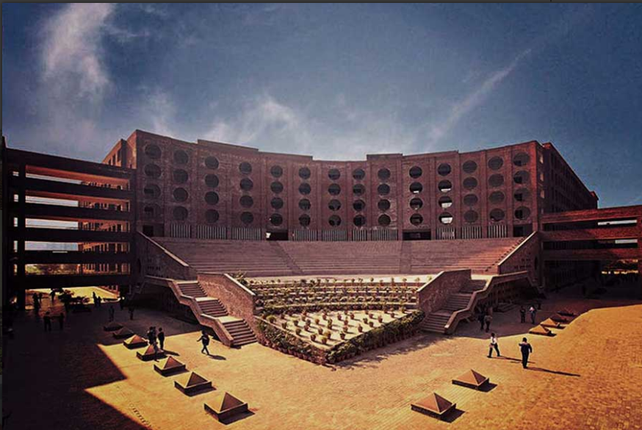
The menu option in the homepage has subparts like home, book room, services, about us, customer care.

